Database Technologies – Assignment 7

Use appropriate joins to solve following queries.
Note: To solve below queries, use “sales” database.
- Write a query that lists each order number followed by the name of the customer who made the order.

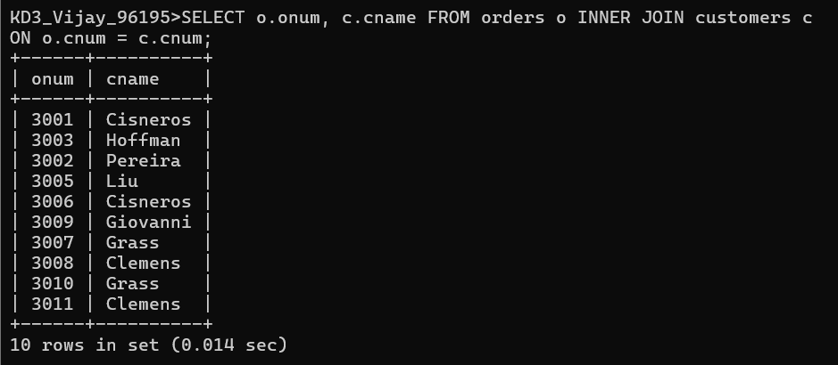

- Write a query that gives the names of both the salesperson and the customer for each order along with the order number.

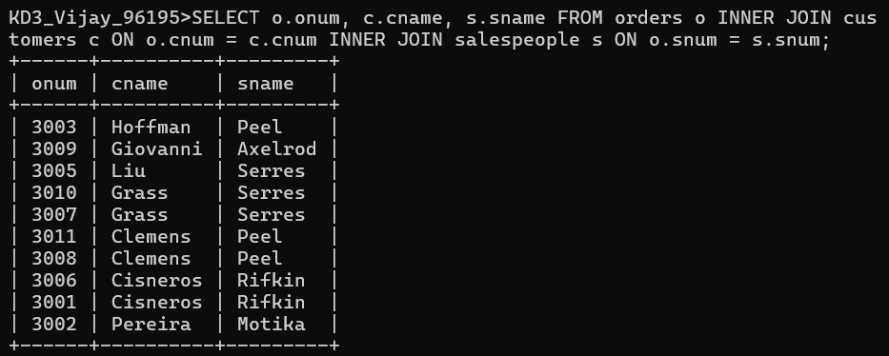

- Write a query that produces all customers serviced by salespeople with a commission above 12%. Display the customer’s name, the salesperson’s name, and the salesperson’s rate of commission.

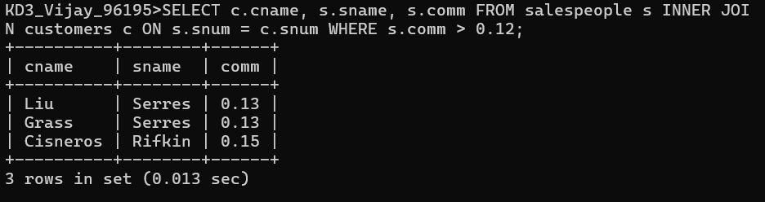

- Write a query that calculates the commission earned by each salesperson for orders placed by customers with a rating above 100.

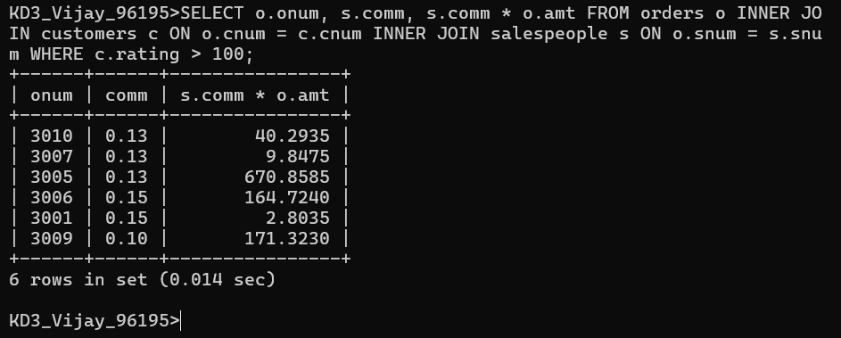

- Write a query that produces all pairs of salespeople who are living in the same city. Exclude combinations of salespeople with themselves as well as duplicate rows with the order reversed .

